**Oct 1, 2020**

1. Please follow the step1 and step2 Udemy courses, they will be really helpful to build up the career foundation in development using Python:

Ste:1

<https://www.udemy.com/course/the-python-fitness-program/?src=sac&kw=python+100>

Step:2

Learning with blockchain

<https://www.udemy.com/course/the-complete-developers-guide-to-blockchain/>

Study Materials Link, please go through the videos and do practice:

<https://drive.google.com/drive/folders/1z-Qcyrjli3K-xcLZeZ3QYaCp1rUx0ID5>

Learning objective: Get familiar with Python

2. Find the attached file for reviewing and writing a very short summary (Maximum 1 page). Refer following image for the article you have to review:

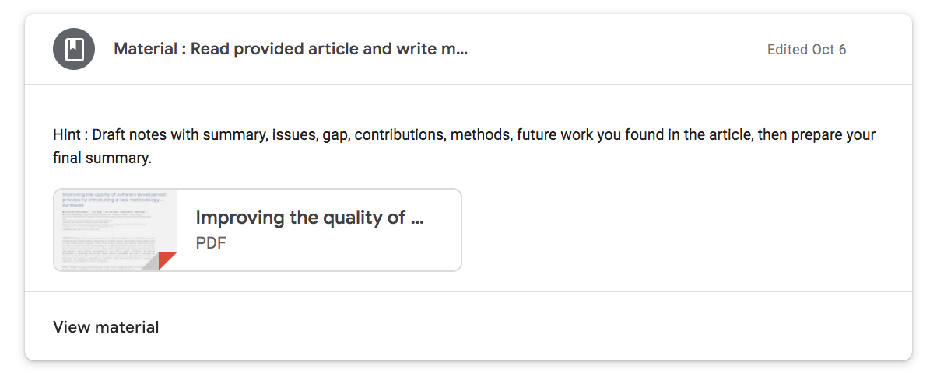

**To Do:**

-Screening - Title; Abstract, Conclusion…

-Taking Notes on the short list articles - summary, issues, gap, contributions, methods, future work

Learning Objectives : You will be familiar with the research articles and prepare their summary, which will be helpful when you need to refer the scientific articles or journal articles in your future research or reference.

**Oct 7/8, 2020**

*Assignment Revision(Review the journal paper) and Udemy Course - 2Weeks

-Searching Relevant work - google; google scholar, <https://ieeexplore.ieee.org/>

-Screening - Title; Abstract, Conclusion…

-Taking Notes on the short list articles - summary, issues, gap, contributions, methods, future work

*16-CSY2027 research-methods.ppt -> CC PPT : Study on the Impact of Modular Security Architecture Implementation in the Cloud Service Performance

**Oct 15/16, 2020**

**\***Update about the daily attendance in google classroom

**\***Re-cap last class

*Discuss House Painting WBS activities in a class -

*Go through "How to Build a WBS.docs"?

*Explain example of software development WBS, keeping the project level at top, "Sample WBS structure keeping project level at the top.docs"

*Explain "cpa.ppt" and “cpa_gantt_chart.xlsx” in details.

-Class Work1, 2, 3

*Assignment - WBS….pdf, and develop WBS for one of the WBS you have prepared.

*Assignment - Assignment - WBS, Network Diagram, Gantt Chart, CPA, please refer following image for the details of assignment posted your google classroom:

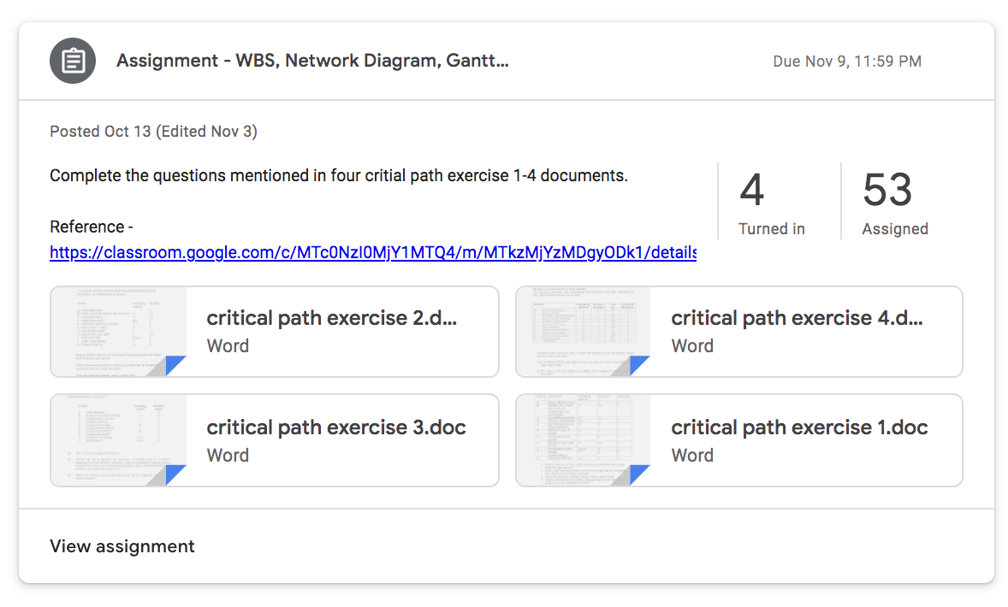

**Nov 6, 2020 (Combined Group A & B)**

Re-cap last class - draw.io

Python Course Status

Assignment - WBS

**Walkthrough - Sample Group Project Report - group E.pdf**

Assignment -

Blockchain-based-E-Voting-Simulation -<https://github.com/GottfriedCP/Blockchain-based-E-Voting-Simulation>

Blockchain-eVoting -<https://github.com/tripmani/Blockchain-eVoting>

Learning Objectives: You will be download github project and run in your local environment, so that it will be helpful in your group project in the future.

**Assignment** - Walk through with **10GP Software Testing-Evaluation** (Basic Concepts).docx, Sample Test_Scenario_Cases.xlsx, please refer the following image for the reference materials posted in google classroom:

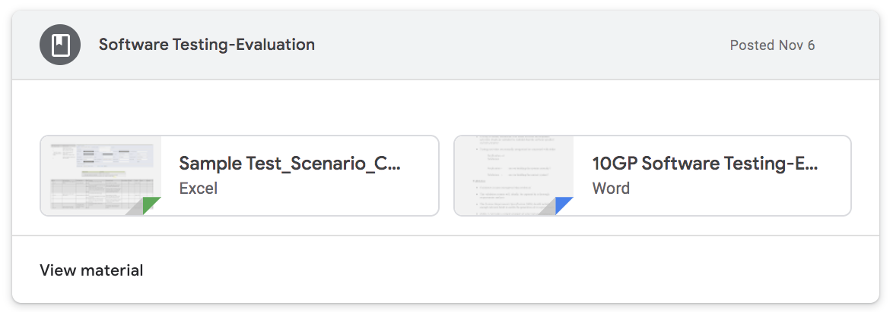

After reading above study materials, now you can refer following image for the assignment work.

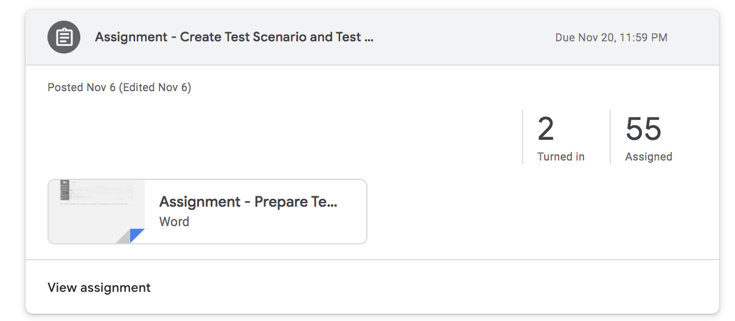

Learning Objective: Develop test scenario and test cases for your group project, and also get ready to take a QC or QA role in the industry.

**Nov 12/13, 2020**

Software Project Management - 01 - Software Management Part I & II…docx

Client Elicitation Interviews - 02 - Client Elicitation Interviews….docx

Please refer following image for your study, please study them so that we can discuss in our class:

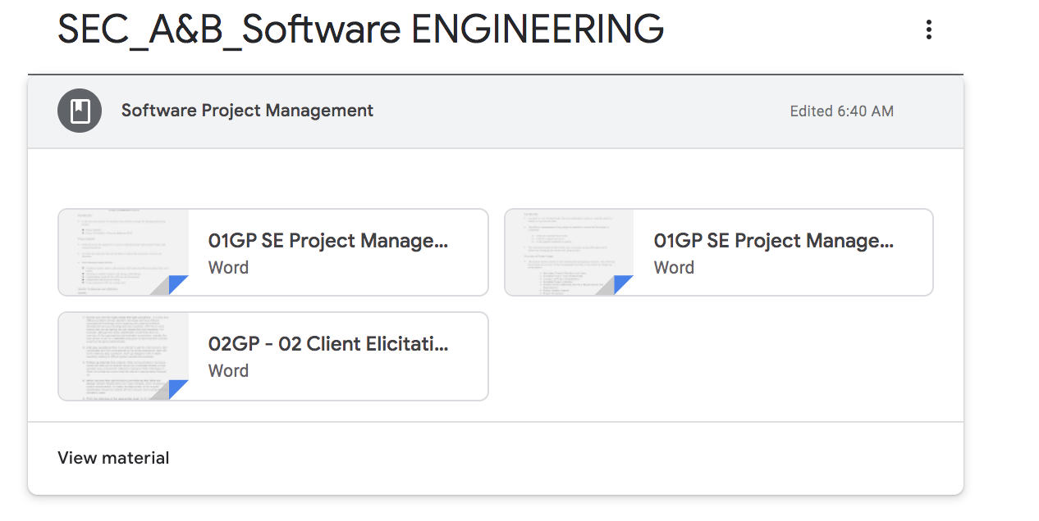

Learning Objectives : You will be able to prepare and refine client interview for the requirements, and Qality management aspects in Software project management.

**Nov 20, 2020**

Just review with the assignments

**Nov 26, 2020**

Review with the assignments

Re-cap to previous study

Assignment Summary:

************

************Task-1: Python Study

************

Step:1

<https://www.udemy.com/course/the-python-fitness-program/?src=sac&kw=python+100>

Step:2

Learning with blockchain

<https://www.udemy.com/course/the-complete-developers-guide-to-blockchain/>

************

************Task-2: Summary Writing

************

2. Find the attached file for reviewing and writing a very short summary (Maximum 1 page).

************

************Task-3: WBS

************

*Assignment - WBS….pdf, and develop WBS for one of the WBS you have prepared.

************

************Task-4: Assignment - WBS, Network Diagram, Gantt Chart, CPA

************

*Assignment - Assignment - WBS, Network Diagram, Gantt Chart, CPA

************

************Task-5: Github project implement

************

Assignment -

Blockchain-based-E-Voting-Simulation -<https://github.com/GottfriedCP/Blockchain-based-E-Voting-Simulation>

Blockchain-eVoting -<https://github.com/tripmani/Blockchain-eVoting>

************

************Task-6: Walk through group project document

************

************

************Task-7: Assignment - Walk through with 10GP Software Testing-Evaluation (Basic Concepts).docx, Sample Test_Scenario_Cases.xlsx

************